**Student name, year, hometown, major**

Diego Barahona; Junior; Tegucigalpa, Honduras; Biochemistry and Environmental Sustainability

Kat Lehman; Sophomore; Dover, Ohio; Biology

**A picture**

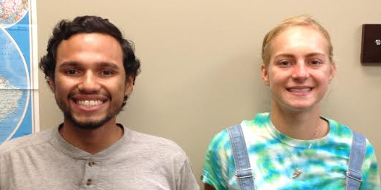

**A title**

Judas Beetles: Discovering Cryptic Breeding Sites by Radio-tracking Coconut Rhinoceros Beetles

**A 150 word abstract**

The coconut rhinoceros beetle (CRB), *Oryctes rhinoceros* L., is a serious pest of coconut trees and other palms throughout the Pacific and Southeast Asia. Typically CRB populations are controlled with a combination of biocontrol, pheromone traps, and breeding site removal. This study used radio-tagged CRBto track beetle movement at two locations on Guam. Nineteen CRB were successfully tracked to five different microhabitats. Percent emergence weight (%EW) varied significantly by the microhabitat to which CRB were tracked. When microhabitats were further grouped, the difference in mean %EW between the arboreal (74 ± 2%) and the soil-associated (82 ± 3%) groups were found to be highly significant. The %EW for CRB that were successfully located (78 ± 2%) and lost CRB (72 ± 2%) also differed significantly. Tracking CRB in this manner shows good promise as a method to identify cryptic breeding sites, which could then be treated, removed, or destroyed.

**A 150 word (amusing) bio**

Diego was born in Tegucigalpa, Honduras to a journalist couple. He finished high school at Academia Los Pinares, and, although generationally pressured to follow the communications route, he decided to pursue the cold, clinical world of the natural sciences to fulfill his dream of becoming a mad scientist with an evil laugh someday. At EMU, he has been involved in multiple activities particularly Campus Ministries, Rec Sports, and the PPHS Club. He spent this past summer traveling the world with Dr. Siderhurst and fellow student Kat Lehman doing research to figure out new ways to get rid of annoying insects.

Firstborn daughter of an emergency room physician and a teacher of English literature, Kat grew up geeking out on science and art alike. Among other quirky and varied hobbies, reading, knitting, antiquing, running, butterfly collecting, and homemade "science experiments" filled much of her free time throughout middle school and high school. While the rural Ohio town in which she grew up offered little in the way of mutual enthusiasm for pretty much all aforementioned pursuits, Kat has found many fellow nerds here at EMU. Here in fellowship with other science enthusiasts she hopes to pursue a degree as a medical doctor while engaging in exotic research projects on the side.